Inbound Traffic

⬇️ What Is Inbound Traffic in Networking?
# Source: AI Source: Provided by: [Data Path: Persons Table -> ID Column: 1, Name_En Column: Motasem Essam] -> From: [ChatGPT] on [12/9/2025]
Inbound traffic refers to all data that enters a network, device, or server from an external source. It's the incoming traffic that travels from outside → into your system.

📦 Belongs to:
# Source: AI Source: Provided by: [Data Path: Persons Table -> ID Column: 1, Name_En Column: Motasem Essam] -> From: [ChatGPT] on [12/9/2025]
✅ Network Traffic Direction
(along with Outbound Traffic — the opposite flow)

📡 Examples of Inbound Traffic:
# Source: AI Source: Provided by: [Data Path: Persons Table -> ID Column: 1, Name_En Column: Motasem Essam] -> From: [ChatGPT] on [12/9/2025]
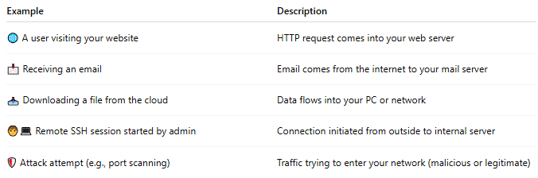

Example | Description
🌐 A user visiting your website | HTTP request comes into your web server
📩 Receiving an email | Email comes from the internet to your mail server
📥 Downloading a file from the cloud | Data flows into your PC or network
🧑‍💻 Remote SSH session started by admin | Connection initiated from outside to internal server
🛡️ Attack attempt (e.g., port scanning) | Traffic trying to enter your network (malicious or legitimate)

🔐 Why Inbound Traffic Matters
# Source: AI Source: Provided by: [Data Path: Persons Table -> ID Column: 1, Name_En Column: Motasem Essam] -> From: [ChatGPT] on [12/9/2025]
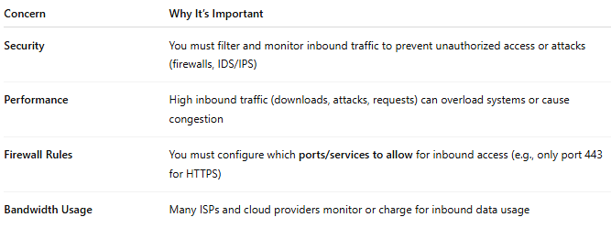

Concern | Why It’s Important
Security | You must filter and monitor inbound traffic to prevent unauthorized access or attacks (firewalls, IDS/IPS)
Performance | High inbound traffic (downloads, attacks, requests) can overload systems or cause congestion
Firewall Rules | You must configure which ports/services to allow for inbound access (e.g., only port 443 for HTTPS)
Bandwidth Usage | Many ISPs and cloud providers monitor or charge for inbound data usage

🆚 Inbound vs Outbound Traffic
# Source: AI Source: Provided by: [Data Path: Persons Table -> ID Column: 1, Name_En Column: Motasem Essam] -> From: [ChatGPT] on [12/9/2025]
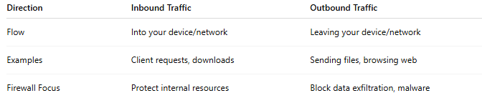

Direction | Inbound Traffic | Outbound Traffic
Flow | Into your device/network | Leaving your device/network
Examples | Client requests, downloads | Sending files, browsing web
Firewall Focus | Protect internal resources | Block data exfiltration, malware

📌 Summary
# Source: AI Source: Provided by: [Data Path: Persons Table -> ID Column: 1, Name_En Column: Motasem Essam] -> From: [ChatGPT] on [12/9/2025]
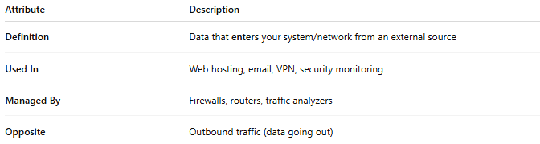

Attribute | Description
Definition | Data that enters your system/network from an external source
Used In | Web hosting, email, VPN, security monitoring
Managed By | Firewalls, routers, traffic analyzers
Opposite | Outbound traffic (data going out)

